决策树实现钢包预配包
1.结论摘要
利用决策树算法，并使用 PLAN.xlsx 与 CRANE.xlsx 的对齐生产数据完成离线预配包评测。决策树先筛选钢包和行车候选，再由既有硬约束终检作最终裁决。
2.规则决策树预配包方法
炉次按优先级进入分配流程。对于每个炉次，算法遍历可用钢包与在线行车，先执行钢包规则，再执行行车硬约束终检。只有同时通过的组合才会进入评分排序。分配成功后，钢包从可用池移除，行车负载按既有评测语义更新；候选耗尽时输出未分配原因或人工复核处置。
步骤 | 判定与输出
1. 输入完整性 | 检查炉次号与所需等级；缺失关键字段时输出 request_human_review。
2. 钢包状态/维修/吹氩 | 过滤离线、检修、报废和吹氩条件不满足的钢包。
3. 等级/包龄/重量/前炉钢种 | 执行等级匹配、包龄、空包重量、前炉钢种等红线筛选。
4. 行车载荷/时间窗/安全距离 | 复用硬约束终检，计算可达性、额定载荷与安全距离。
5. 黄色告警评分 | 在全部硬约束通过后按等级、包龄、时间窗、负载均衡和稀缺度排序；输出 assign 或未分配原因。
3、约束体系与审计输出
约束类别 | 典型条件 | 系统处置
工艺与钢包红线 | 等级不匹配、离线/检修状态、包龄超限、重量越界、吹氩或维修不满足 | 拒绝候选并记录违规原因
行车安全红线 | 载重超限、到达时间超过窗口、安全距离不足 | 拒绝候选并尝试下一组合
关键输入缺失 | 炉次号或所需等级缺失 | 不自动分配，输出 request_human_review
黄色告警 | 如钢包状态字段缺失 | 保留警告进入审计路径；不以告警单独替代红线终检
4.代码展示
炉次按优先级进入分配流程。对于每个炉次，算法遍历可用钢包与在线行车，先执行钢包规则，再执行行车硬约束终检。只有同时通过的组合才会进入评分排序。分配成功后，钢包从可用池移除，行车负载按既有评测语义更新；候选耗尽时输出未分配原因或人工复核处置。
核心入口：allocate() 主循环：候选遍历→硬约束过滤→评分排序→资源更新→钢包释放
def allocate(heats: list[dict[str, Any]], ladles: list[dict[str, Any]], cranes: list[dict[str, Any]]) -> list[DecisionTreeAssignment]:
"""Run the documented tree nodes, then use shared validator as final authority."""
base_loads = {str(c["crane_id"]): max(0.0, float(c.get("current_load_tonnes", 0) or 0)) for c in cranes}
transported_loads = dict(base_loads)
crane_positions = {str(c["crane_id"]): float(c.get("position_m", 0) or 0) for c in cranes}
available = list(ladles)
result: list[DecisionTreeAssignment] = []
ordered_heats = sorted(
heats,
key=lambda h: (
-float(h.get("priority", 0) or 0),
float(h.get("window_start", float("inf")) or 0),
str(h.get("heat_id", "")),
),
)
for heat in ordered_heats:
missing = _required_missing(heat)
if missing:
result.append(DecisionTreeAssignment(str(heat.get("heat_id", "unknown")), None, None, None, False, "关键输入缺失，人工复核", action="request_human_review", decision_path=("input_complete:fail." + ".".join(missing),)))
continue
options: list[tuple[float, dict[str, Any], dict[str, Any], tuple[str, ...]]] = []
rejected: list[str] = []
for ladle in available:
rules = evaluate_ladle_rules(heat, ladle)
if not rules.feasible:
rejected.extend(rules.violations)
continue
for crane in cranes:
crane_id = str(crane["crane_id"])
candidate_crane = {**crane, "position_m": crane_positions[crane_id]}
errors = validate_assignment(heat, ladle, candidate_crane, base_loads)
if errors:
rejected.extend(errors)
continue
path = (
"input_complete:pass",
"ladle_state_repair_argon:pass",
"grade_age_weight_previous_grade:pass",
"crane_load_time_safety:pass",
"yellow_rule_score:" + ("warn." + ".".join(rules.warnings) if rules.warnings else "pass"),
)
options.append((score_candidate(heat, ladle, candidate_crane, transported_loads, available), ladle, candidate_crane, path))
if not options:
action = "request_human_review" if not cranes or any(item.startswith("missing.") for item in rejected) else "unassigned"
reason = "无可行候选：" + (",".join(sorted(set(rejected))) if rejected else "钢包或行车不可用")
# Rejected candidates are diagnostic evidence, not violations of an applied assignment.
result.append(DecisionTreeAssignment(str(heat["heat_id"]), None, None, None, False, reason, (), action, ("candidate_exhausted",)))
continue
_, ladle, crane, path = max(options, key=lambda item: item[0])
crane_id = str(crane["crane_id"])
transported_loads[crane_id] += max(0.0, float(ladle.get("weight_tonnes", 0) or 0))
crane_positions[crane_id] = float(ladle.get("position_m", crane_positions[crane_id]) or crane_positions[crane_id])
# No real-time ladle lifecycle is available. Treat a completed transport
# as an immediate release, allowing the same ladle to serve the next heat.
result.append(DecisionTreeAssignment(str(heat["heat_id"]), str(ladle["ladle_id"]), crane_id, _arrival(heat, ladle, crane), True, "规则决策树→真实行车距离/作业均衡→硬约束终检→本次转运后钢包释放", (), "assign", path + ("crane_distance_and_workload:scored", "ladle_reuse:immediate_release",)))
return result

决策树配置
TREE_VERSION = "spec-rule-tree-v1"
NODE_ORDER = (
"input_complete",
"ladle_state_repair_argon",
"grade_age_weight_previous_grade",
"crane_load_time_safety",
"yellow_rule_score",
)

约束代码：
"""Machine-checkable subset of the ladle rules in the functional specification."""
from __future__ import annotations

from dataclasses import dataclass
from typing import Any

from ladle_preallocation.data_modeling.grades import grade_matches

@dataclass(frozen=True)
class RuleEvaluation:
violations: tuple[str, ...] = ()
warnings: tuple[str, ...] = ()

@property
def feasible(self) -> bool:
return not self.violations

def _number(value: Any) -> float | None:
try:
return None if value in (None, "") else float(value)
except (TypeError, ValueError):
return None

def _required_argon(heat: dict[str, Any]) -> tuple[bool, bool]:
route = str(heat.get("refining_route", "")).upper()
return bool(heat.get("requires_north_argon") or "LF" in route or "LATS" in route), bool(heat.get("requires_south_argon") or "LF" in route)

def evaluate_ladle_rules(heat: dict[str, Any], ladle: dict[str, Any]) -> RuleEvaluation:
"""Evaluate documented red/yellow ladle rules against available fields."""
red: list[str] = []
yellow: list[str] = []
if not grade_matches(heat.get("required_grade"), ladle.get("grade")):
if heat.get("enforce_grade"):
red.append("grade")
else:
yellow.append("grade_not_enforced")
state = str(ladle.get("state", "")).lower()
allowed_states = {str(x).lower() for x in heat.get("allowed_ladle_states", [])}
if state in {"offline", "unavailable", "maintenance", "scrapped"}:
red.append("ladle_state")
elif allowed_states and state and state not in allowed_states:
red.append("ladle_state")
elif not state:
yellow.append("missing.ladle_state")
age = _number(ladle.get("age_seconds"))
max_age = _number(ladle.get("max_age_seconds"))
if age is not None and max_age is not None and age > max_age:
if heat.get("enforce_ladle_age"):
red.append("age")
else:
yellow.append("age_not_enforced")
weight = _number(ladle.get("empty_ladle_weight_tonnes"))
lower = _number(heat.get("min_empty_ladle_weight_tonnes", 127.0))
upper = _number(heat.get("max_empty_ladle_weight_tonnes", 155.0))
if weight is None:
yellow.append("missing.empty_ladle_weight")
elif (lower is not None and weight < lower) or (upper is not None and weight > upper):
if heat.get("enforce_empty_ladle_weight"):
red.append("empty_ladle_weight")
else:
yellow.append("empty_ladle_weight_not_enforced")
north_required, south_required = _required_argon(heat)
for field, required in (("argon_north_ok", north_required), ("argon_south_ok", south_required)):
if required and ladle.get(field) is False:
red.append(field)
elif required and ladle.get(field) is None:
yellow.append(f"missing.{field}")
if heat.get("forbid_major_repair") and str(ladle.get("repair_type", "")).lower() in {"major", "full"}:
red.append("repair_type")
if heat.get("forbidden_previous_grade") and str(ladle.get("previous_steel_grade", "")).upper() == str(heat["forbidden_previous_grade"]).upper():
red.append("previous_steel_grade")
return RuleEvaluation(tuple(red), tuple(yellow))

5、预配包结果
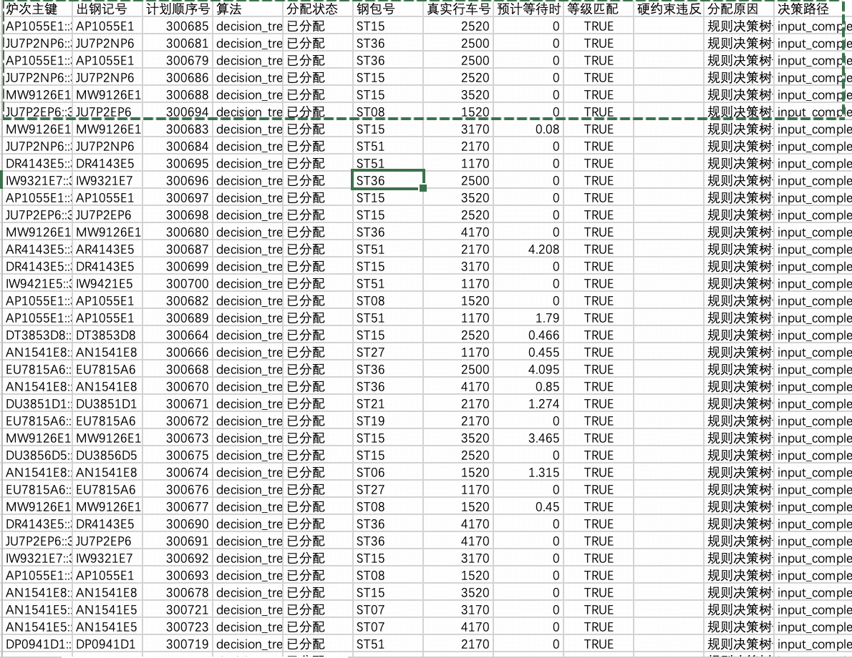
这里只展示一部分预配包的效果。全部的预配包已完成，包含 416 条炉次结果、钢包号、真实行车号、等待时间、约束检查、分配原因和决策路径。全部分配成功，硬约束违规为 0，相关测试 5/5 通过。
6、下一步工作
对预配包的结果建立评分指标体系，评判当前决策树预配包效果的好坏，为后续引入llm进行预配包优化奠定基础。目前的设想是：模拟系统出现扰动，对目前的已经分配的钢包结果进行评价看是否能够经受住扰动，得到一个指标率，后续对该效率进行提升。

=

